**11 - fY%aKsh**

* **;siai rKisxy Ys,amshd ^1925&**

kQ;k uQ¾;s l,dfõ kj ffY,shla ìys lsÍug mqfrda.dó jQ fudyq foaYSh jYfhka yd cd;Hka;r jYfhka iïudkkSh;ajhg m;a jQ wfhls' fÊ'ã'tA'fmf¾rd hgf;a yd fu,ais l,d mdif,ka uQ¾;s Ys,amh yeoErE fudyq iajNdúl yevhkag fjkia jQ jHqla;jdoS yevfhka ;udg wdfõKsl uQ¾;s ffY,shla f.dvk.d f.k we;'

**—1963 oS** úmd; **kï uQ¾;sh i`oyd fudyq úiska ,dxlsl uQ¾;s Ys,amsfhl= ,enQ Wiiau cd;Hka;r iïudkhg ysñlï ,nd we;'˜**

* m%N+kaf.a mqoa., rEm $ úoaj rEm ^wdf,aLH uQ¾;s - mrK ú;dk ms<srej&
* wd.ñl ixl,am ksrEms; uQ¾;s ^fn!oaO yd yskaÿ&
* ÿIalr l%shdj uQ¾;sh $ mõ iudj fyj;a úmdl .fkaI
* ft;sydisl;ajh ksrEms; uQ¾;s
* fld<U rdclSh úoHd,fha Wkak; ks¾udKh fudyqf.a oE;ska ks¾udKh

jQ w.%.kH lD;Ska h'

f,dalv udOH yd jd;a;= lsÍfï Ys,am l%uh y`ÿkajd ÿka fudyq ,dxlsl kQ;k Ys,amSka i`oyd kj m%fõYhla ia:dmkh l< Ys,amshl= f,ig o y`ÿkajd osh yels h'

* **ÿIalr l%shdj uQ¾;sh - ^f,dalv udOH&**

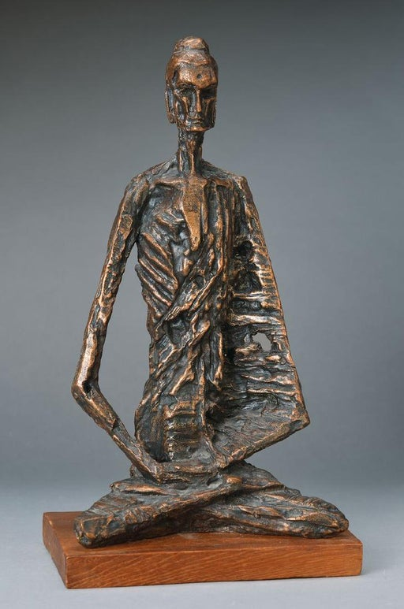

isÿy;a fndai;=kaf.a ÿIalr l%shdj úhqla;jdos l,d wdNdifhka l< úYsIaG ks¾udKhla f,iska y`ÿkajd osh yelsh' fuhska osh ù úhl=Kq udxYuh fldgia yd wiaÓuh ieleiau uekeúka olajd we;' kuq;a iajNdúl ñksia rEmhl ndysr yd ldhsl jHQyhg jvd wNHka;r ye`.Sï ksrEmKh l< yels h:d¾:jdoS ffY,Sh ,laIK o uQ¾;sfhka ksrEmKh fjhs'

* **fld<U rdclSh úoHd,fha Wkak; ks¾udKh**

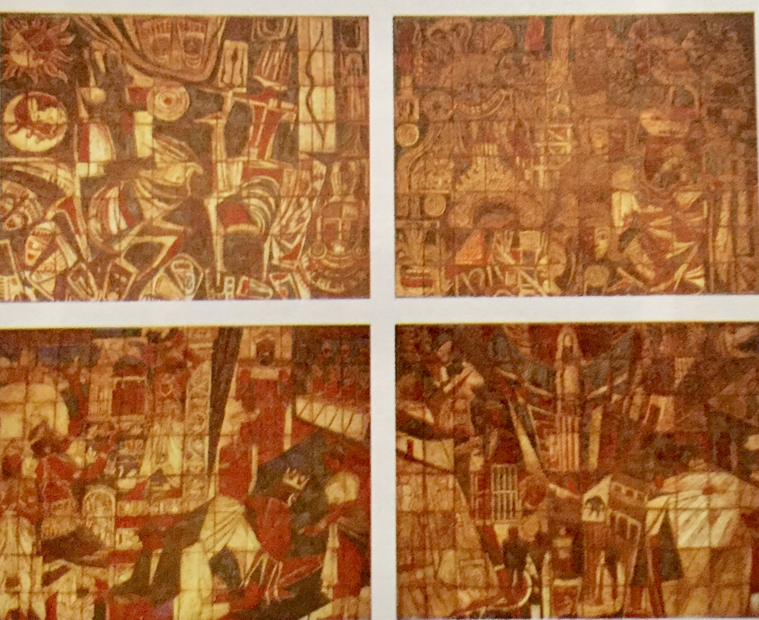

fld<U rdclSh úoHd,fha kj r`.yf,a fgrdfldgd udOH Ndú;dlr ks¾udKh lr we;s ,dxflah kdgH l,d b;sydih kï Wkak; uQ¾;sh ;=,ska >KljdoS úhqla; yev;, j,g wu;rj ffY,s.; yev o fuu ks¾udKh i`oyd mdol lrf.k we;'

* **tï'tA' lreKdr;ak Ys,amshd ^1929&**

Y%S ,xldfõ kQ;k Ñ;% l,dfõ kj iïm%odhla jk úhqla; l,d iïm%odh ìys lsÍug mqfrda.dó jQ fudyq foaYSh jYfhka yd cd;Hka;r jYfhka o iïudkkSh;ajhg md;% jQ wfhls'

rcfha ,,s; l,dh;kfhka Ñ;% yodrd tysu lÓldpd¾hjrhl= f,i fiajh l, fudyq wefußldkq úhqla; m%ldYkjdoS Ñ;% ffY,shg wkq.; jQ úhqla; Ñ;% l,d NdIdj;a ia:dms; lrk ,oS'

* fudyqf.a ks¾udK ;=, uOH.; ixrpkh;a fkdue;s w;r ;,h mqrd yev;, úiqrejd we;'
* ks¾udK i`oyd f;audjla imhd fkdue;s w;r krUkakdg is;Sug wjia:dj ,nd oS we;'
* wd.ñl ye`.Sï cks; jk Ydka; rihla is;=jï ;=, .eíj we;'
* uq,a ld,Sk f;,a idhï udOH fjkqjg miq ld,Skj tlsfkldg fjkia udOH Ndú;d lr we;' ^ weK" ldâfndaâ" kQ,a & fuu.ska ks¾udKfha úreoaO u;=msg iajNdjhkaf.a úúO rihka tlsfkl cks; lrùu;a isÿ lrhs'
* uq,a ld,Skj lekajih u; f;,a idhñka l, ks¾udK
* iomdhd - pkaøldka; mdIdKh
* u, iqj`o - iqÿ j<dl=¿
* uf,l iqj`o - wiajekak
* miq ld,Sk ks¾udK i`oyd úúO udOH Ndú;d lr we;'
* kï fkdl<
* **iomdhd ^1980 - lekajih u; f;,a idhï &**

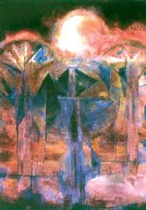

úhqla; m%ldYkjdoS l,d ,laIK ;=,ska ks¾udKh jQ fuu is;=jñka io mEhQ rd;%shl we;s pu;aldrh f¾Ld yd yev;, Ndú;d lrñka ks¾udKh lr we;'

fuu ks¾udKh ;=,ska wd.ñl ye`.Sï iys; jQ Ydka; rihla cks; lrjk nj l,d úpdrl u;h hs'

tfiau is;=jfï we;s rEm ;=,ska ienE iajrEmh fkdfmkajd wNHka;r ye`.Sï wkqj iajNdjh ksrEmKh lr olajd we;'

* **kï fkdl< - ^2011 - tl,ia lsÍfï Ys,am l%uh &**

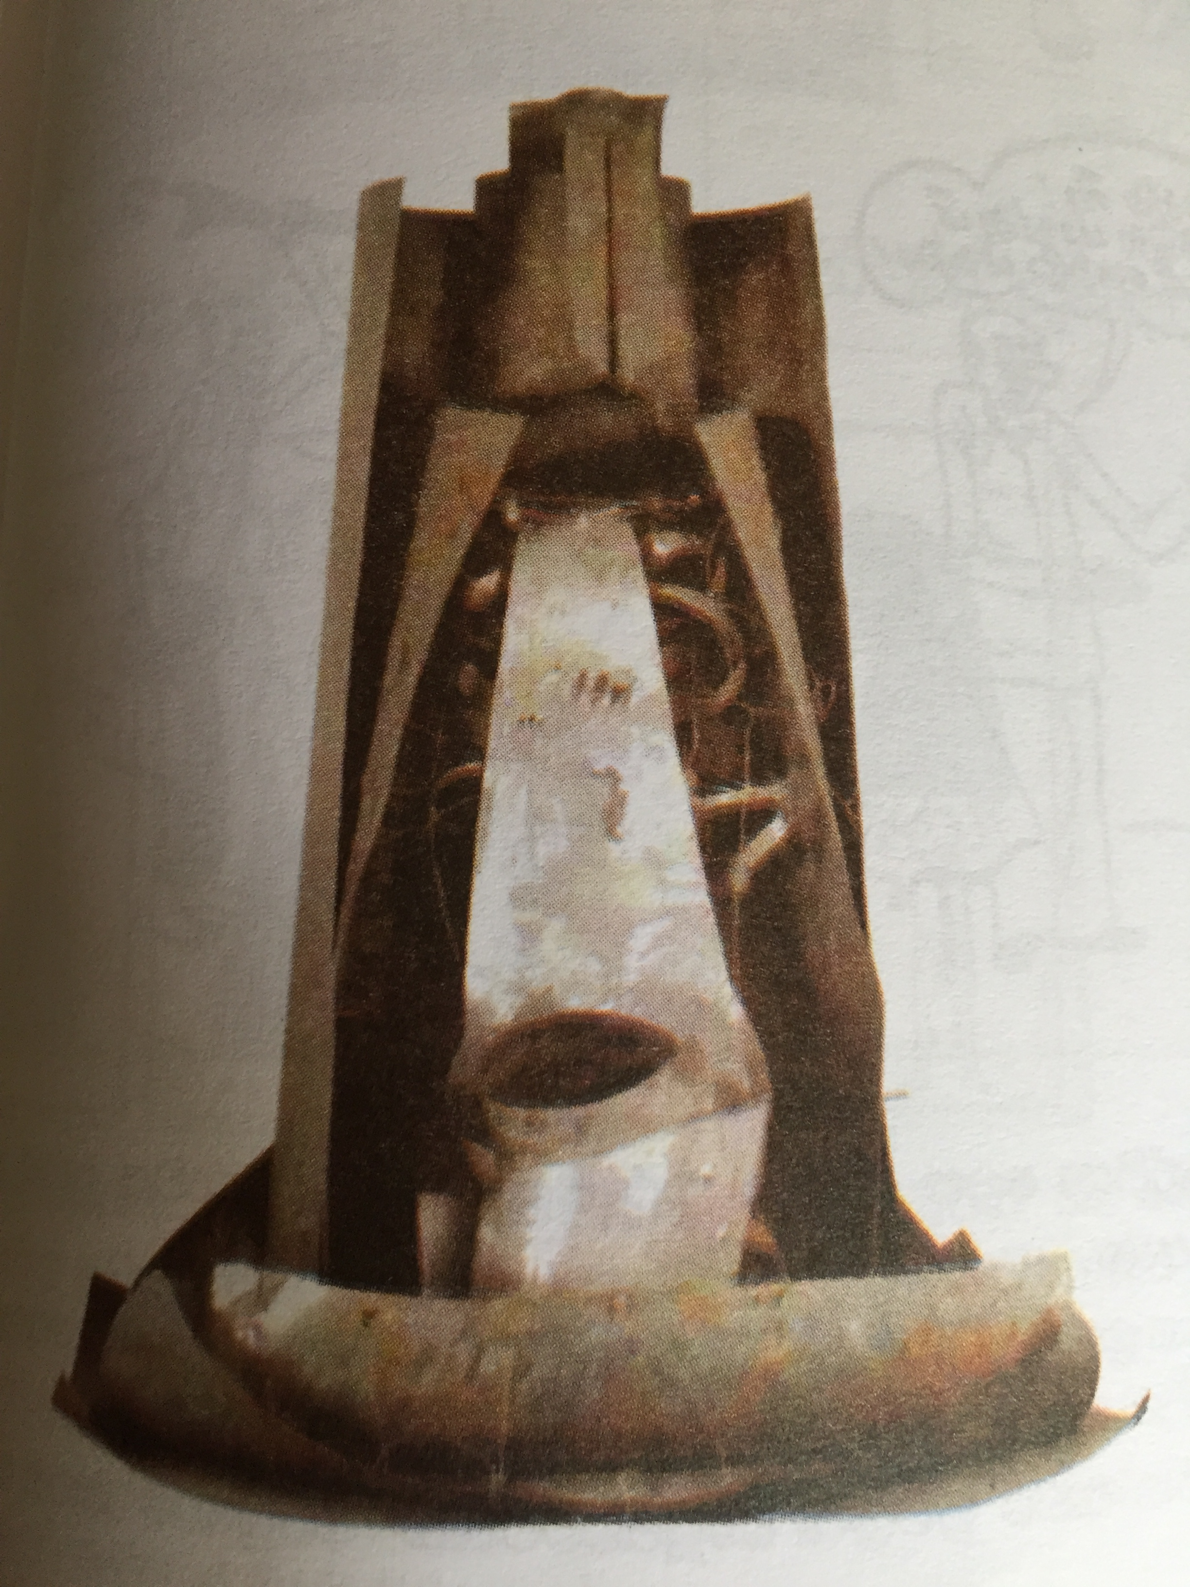

;yvq" lïì" weK hkdos ñY% udOH ^ >k yd r¿ wuq øjH & Ndú;d lr .ksñka úia;rd;aul núka wvq fhda.S bßhõjl oelsh yels uQ,sl ,laIK yd yev;, wkqj tl,ia lsÍfï Ys,am l%uh wkqj fuu uQ¾;sh ks¾udKh lr we;' ixiaf,aIKd;aul >Kljdoh yd tlaldiq l,dfõ wdNdI ,laIK fuu ks¾udKh wdYs%;j oelsh yels fõ'

**fu!¾h" iqx. iy id;jdyk hq.j, ks¾udK**

* **idxÑ ia:Qmh - *wfYdal wêrdcHhd***

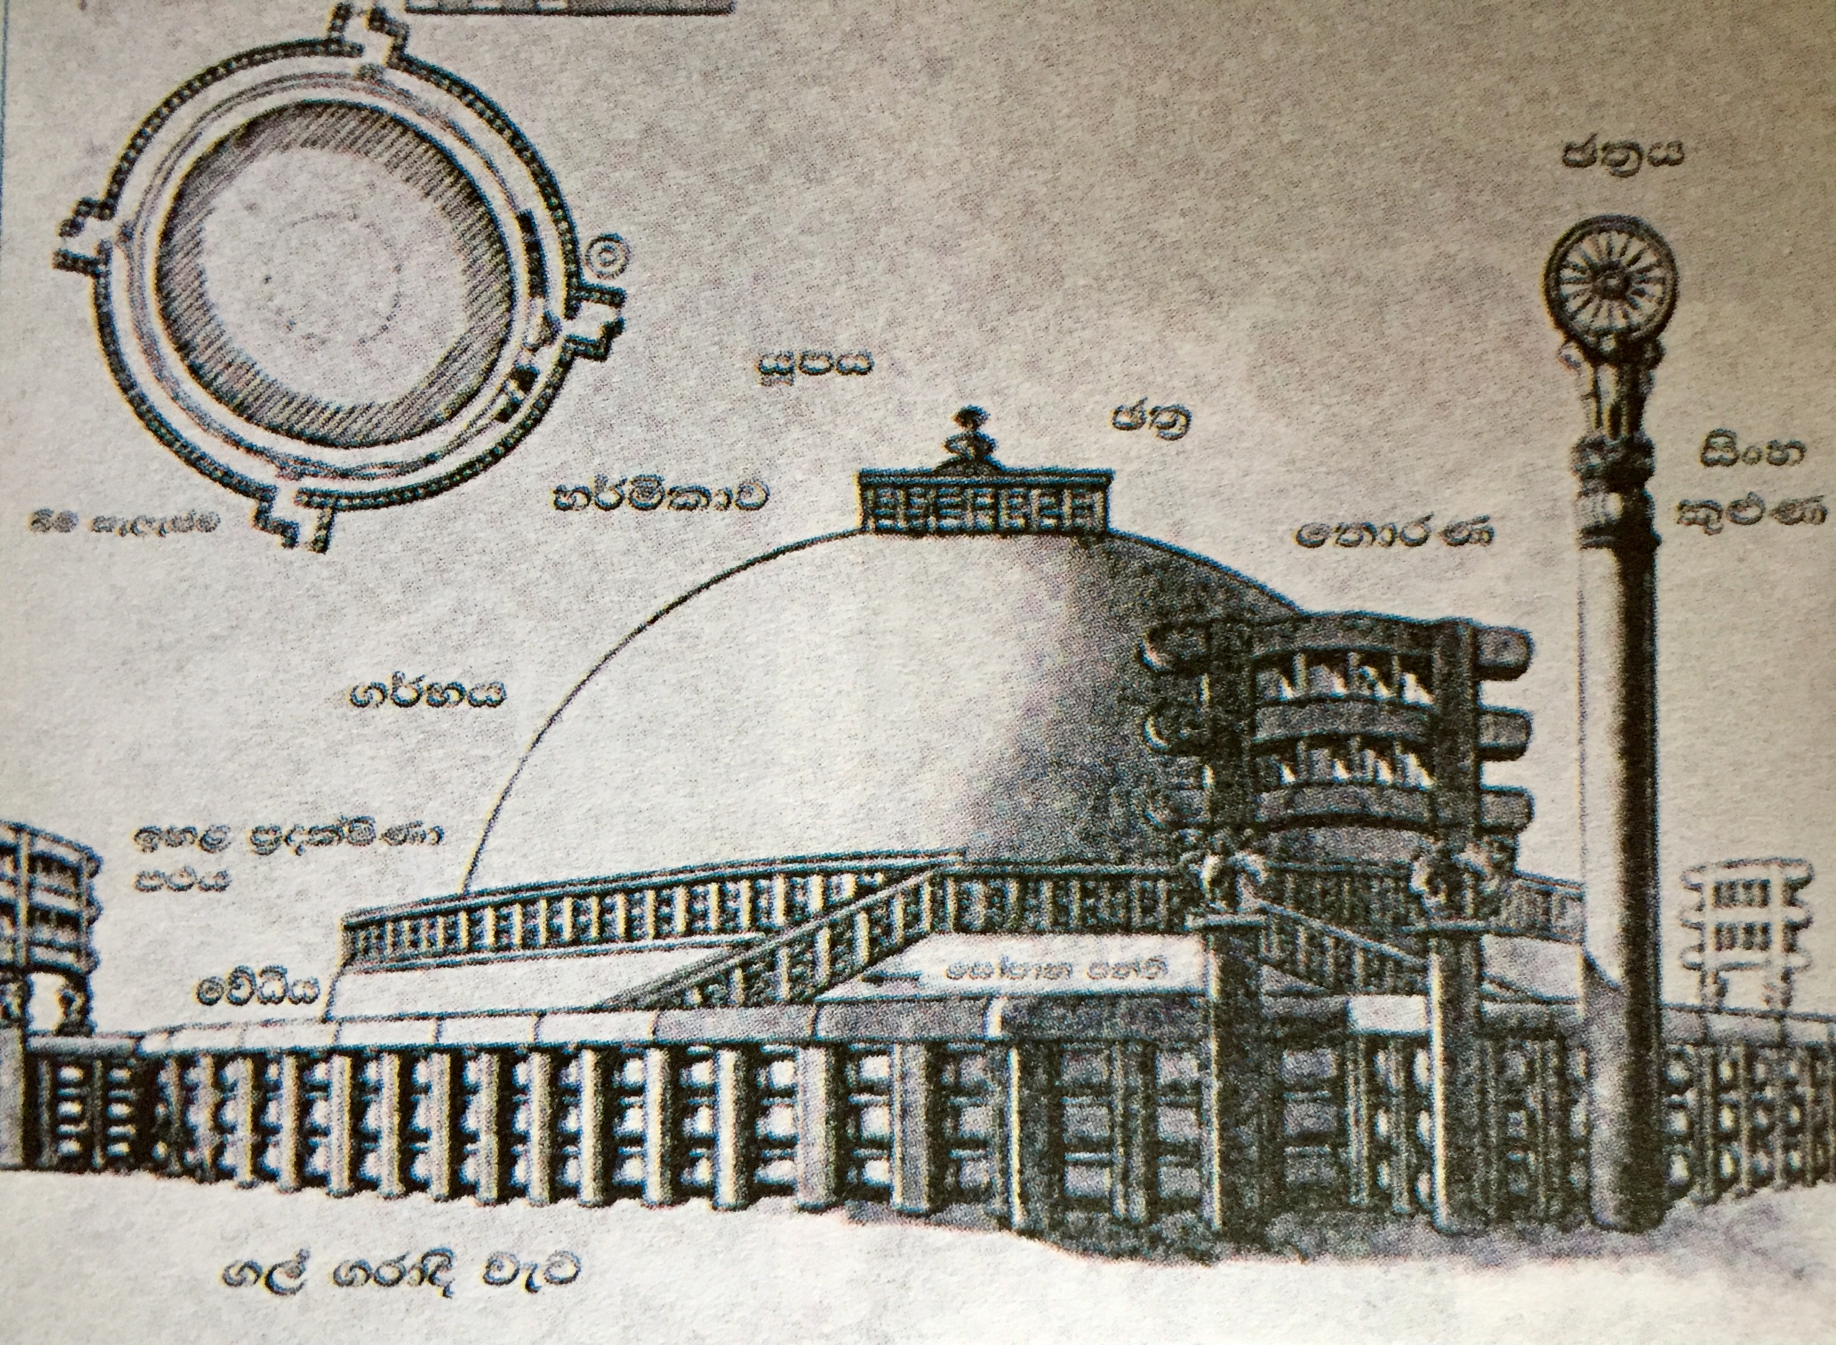

wä 120 l úYalïNhlska yd wä 54 l Wiska hq;a idxÑ ia:Qmfha uyd ia:Qmh uOHu Ndr;fha iqkaor jQ;a l`ÿ .eghla u; msysgd we;'

nqínq,dldr yevfhka hq;a ia:Qmfha

* m%olaIsKd m:h - wä 16 la Wiska hqla; fuh fÉ;sh kñka ye`oska fõ'
* .¾Nh
* y¾ñldj
* hIaáh
* P;% - hIaáhg iïnkaO jQ jD;a;dldr .,a mqjre
* **idxÑ f;drK**

**id;jdyk hq.hg** wh;a idxÑ f;drKA y;ru tlu wdlD;shlg wkqj ks¾udKh ù we;'

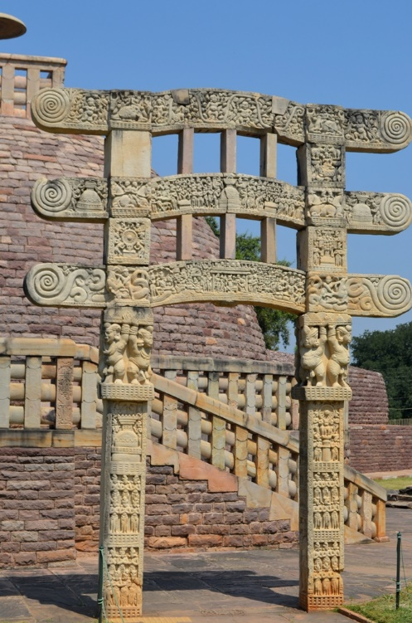

iEu f;drKlu isria l=¨Kq fol u; ;sria Wfv,s m;a ;=kls' tys ol=fKa isg jug jHdma; ù hk wdldrfhka ks¾udKh jQ w,am Wkak; leghï fõ' Wfv,sm;g iïnkaO jQ ;+[a[hla ^ id,nxð;d & kï ia;%S rEm uQ¾;shla lr we;'

f;drK by<skau we;s ;sria .,a mqjre Wfv,sm;a u; **;%SY+,h" ñksia rEm yd i;a;aj rEm ks¾udKh lr we;'**

* **idxÑ f;drfKA leghï i`oyd jia;= úIh jQ f;audjka**
* cd;l l;d - Poaoka; cd;lh" fjiaika;r cd;lh" uydlms cd;lh
* nqoaO pß;fha isoaê - nqÿ ùu" nqÿrÿka ixliaimqrhg jevu lrùu'
* isÿy;a pß;fha isoaê - flaI fÊokh" wNsksIal%uKh
* ft;sydisl isoaê - wfYdal rcq Y%S uyd fndaêh jeoSu" Od;= flda,dy,h
* **idxÑ f;drK leghï ks¾udKj, oelsh yels iqúfYaI ,laIK**
* wLKav l:k l%uhg wkqj cfka,j, ^;sria mQrej,& w,am Wkak; l%uhg b;d ishqïj leghï ks¾udKh lr ;sîu'
* rEmhlg rEmhla uqjdjk fia ;,h u; ixrpkh ùu'
* b;d l=vd bvla we;s ia:dk mjd udkj rEm" i;aj rEm yd YdL yev wjldYh mqrd iïmsKavkh lsÍu'
* ñksia rEm ffY,s.; iajrEmfhka yd i;aj rEm iajNdúl ,laIK iys;j leghï lsÍu'
* i;=kaf.a bßhjq" .;s ,laIK yd p,khka ;d;aúlj ksrEmKh lr oelaùu'
* nqÿka jykafia" isÿy;a l=ure oelaùu i`oyd **fnda.i" P;%h" ia:Qmh" O¾u pl%h yd Y%S mdo ,dxPkh jeks ixfla; fhdod .kq ,eîu'**
* **Poaoka; cd;lh**

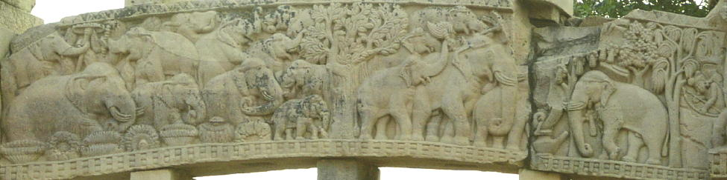

idxÑ f;drKa lsysmhlu fuu cd;l l;dj oelsh yels w;r W;=re f;drfKa we;=,a me;af;a by<u Wfv,smf;ys fuu leghu oelsh yels h' fuhska oelafjkafka kq. .i uq, isák we;=kaf.a o¾YKhls' we;a o;a leghïj, oelsh yels ishqï" ug is,sgq ksudj fuu leghfuka o oel.; yels h'

* **nqÿrcdKka jykafia ixliai mqrhg jevu lsÍu'**

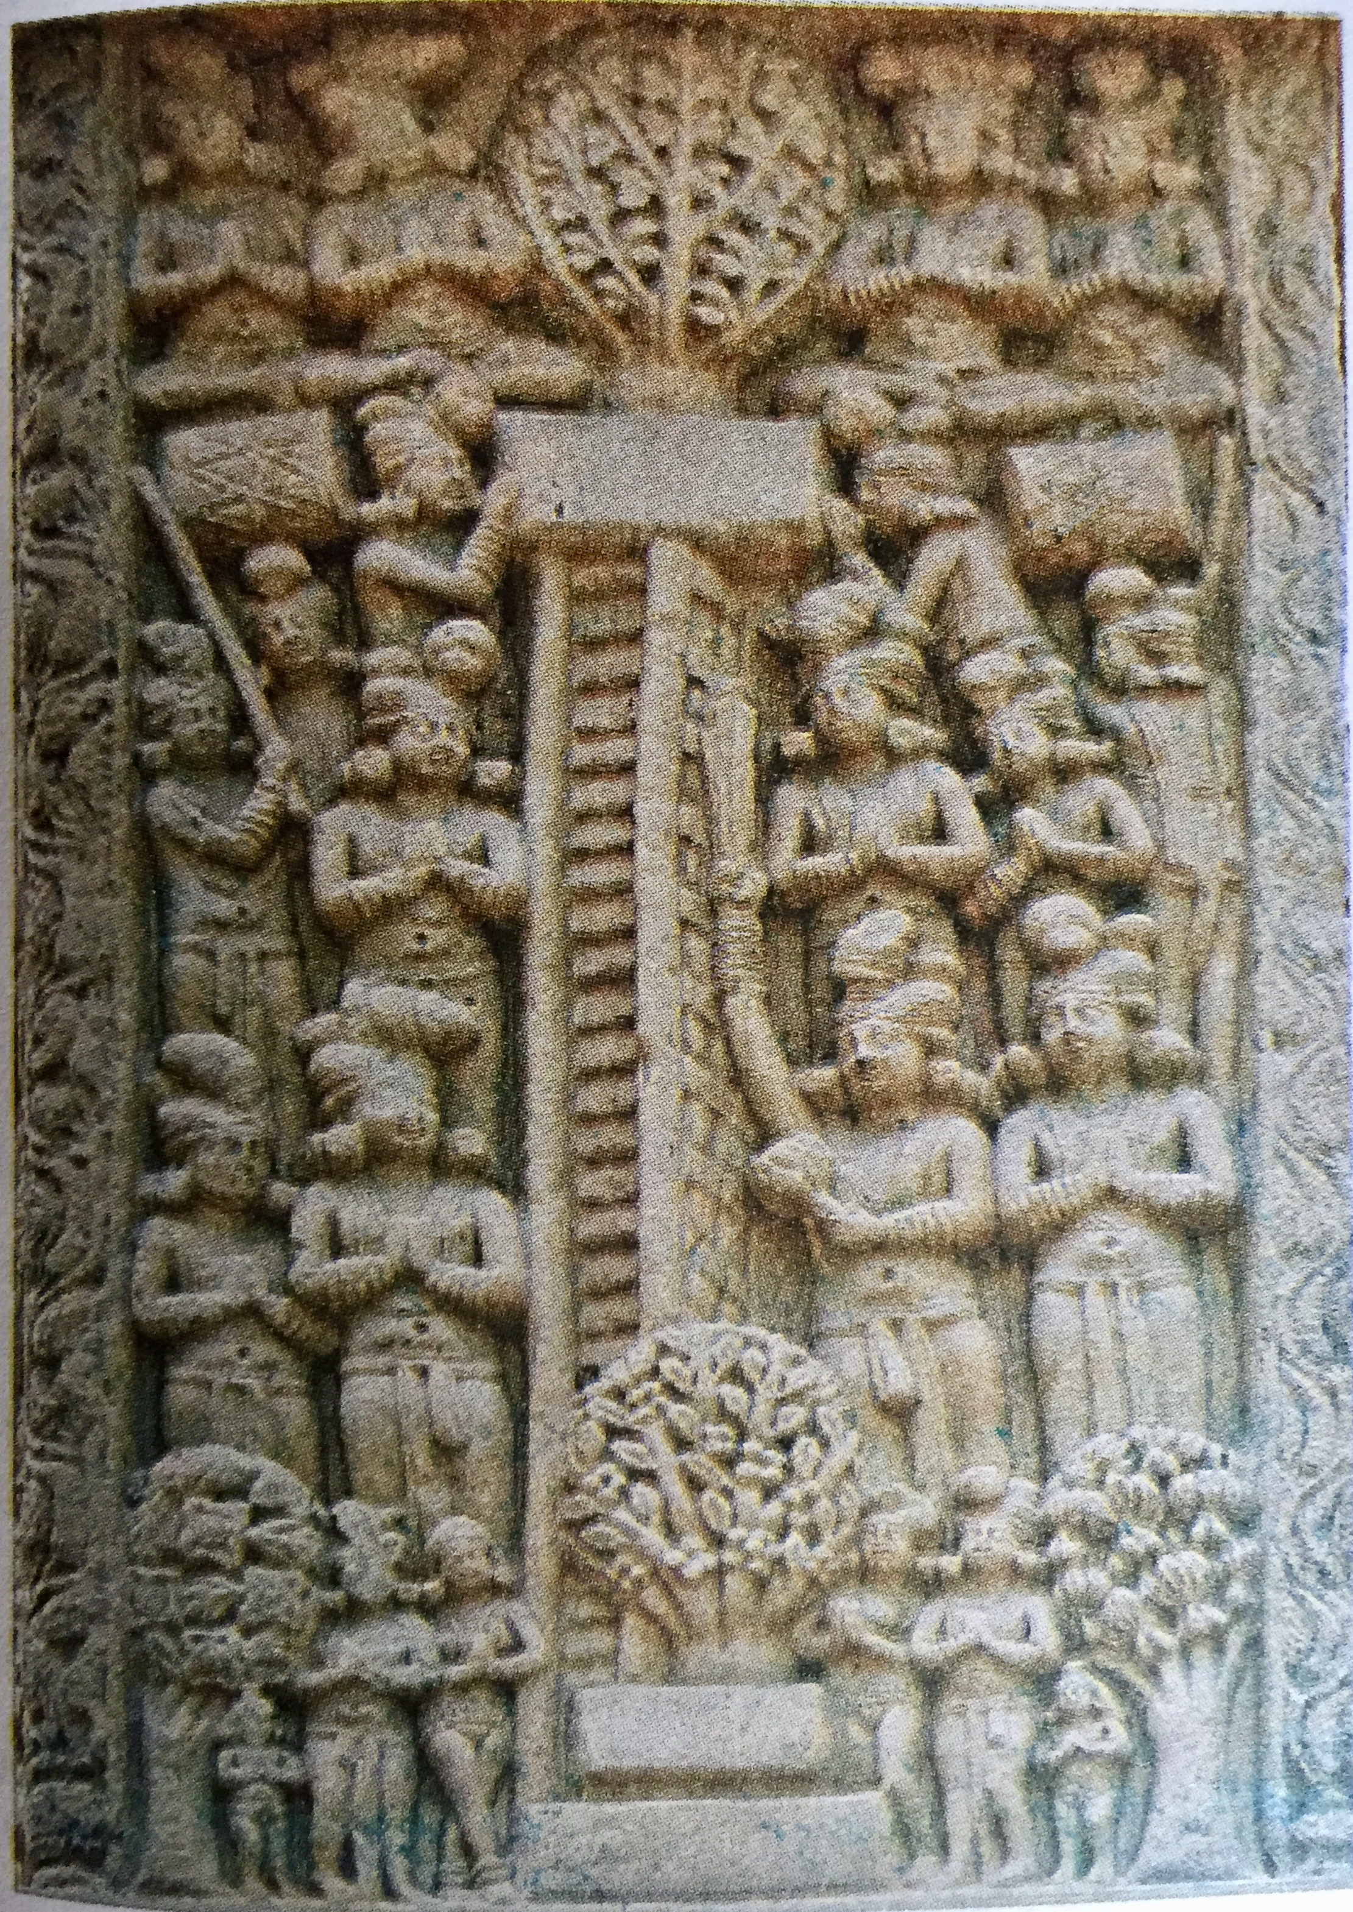

W;=re f;drfKa bosÍ mi we;s fuu leghfuka nqÿka jykafia ixliai mqrhg jeãu ks¾udKh lr we;' nqÿka jykafia fjkqjg fnda.i ixfla;j olajd we;s w;r ñksia rEm ffY,s.; iajNdjfhka leghï lr we;' fuu leghfuka o we;a o;a leghï lrejkaf.a ishqï" ug is,sgq ksudj oelsh yel'

**.=ma; hq.hg wh;a l,d ks¾udK**

* **idrdkd;a nqÿ ms<suh**

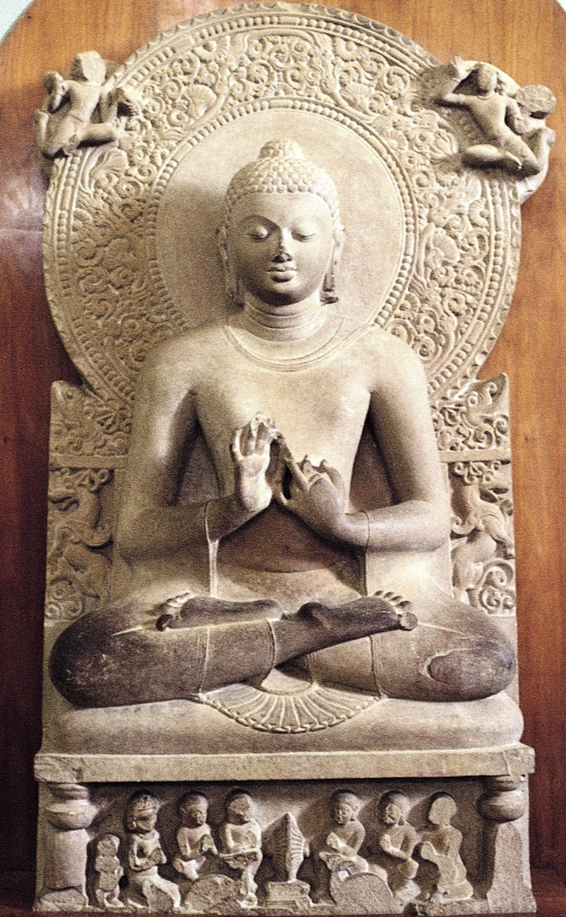

bkaoshdfõ idrdkd;a m%foaYfhka yuq jQ fuu ms<suh pQkd¾ keue;s .,a úfYaIfhka fk<k ,oaols' moaudikhla u; Oïuplal uqødfjka we;s ms<sufh;a m%:u O¾u foaYkdj mj;ajk wjia:dj ksrEms; nj úpdrl u;h hs' jev ys`osk wdik u; O¾u pl%h" uqjka fofok yd nuqKq rEm yh ^ Y%uK rEm & tA wjia:dj ksYaÑ; lrk w;r fojqr jid we;s Öjrh YÍrhg we`tKq iajrEmfhka fmkajd we;s w;r tys ishqï f¾Ld lsysmhla muKla biau;= lr we;'

fuu m%;sudj .=ma; iïm%odhg wh;a w;r j¾;udkfha idrdkd;a fl!;=ld.drfha m%o¾Ykhg

;nd we;'

* **wcka;d Ñ;%**

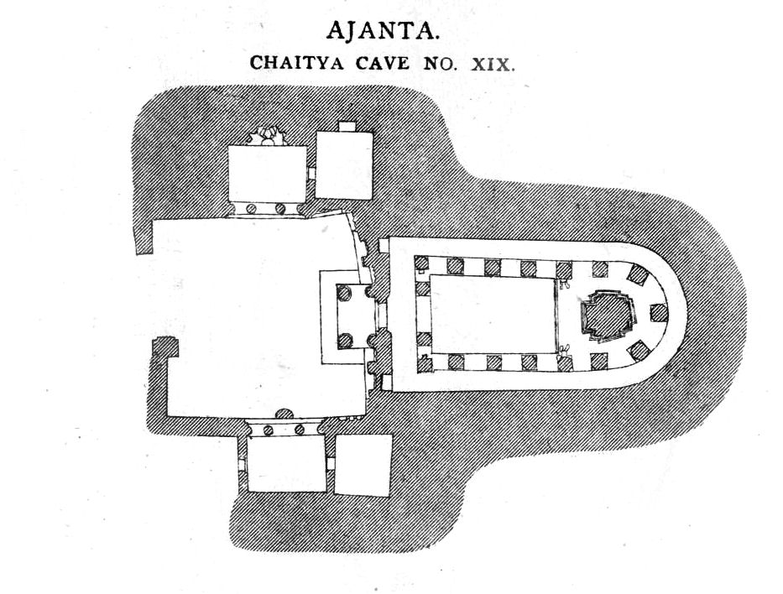

bkaoshdfõ uydrdIag% m%dka;fha yhsøndoa ys jfidard .`.g udhsïj wYaj ,dvul yevfhka hq;a Wia .,a m¾j;hl wcka;d f,ka moaO;sh msysgd we;'

f,ka 29 lska iukaú; fuu ia:dkh l%S'mQ' 2 jk ishjfia isg l%s'j' 7 jk ishji olajd ld, jljdkqjl jßka jr ks¾udKh l, nj;a tys Ñ;% tla mrïmrdjlg wh;a fkdjk nj;a y`ÿkdf.k we;'

* jdia;= úoHd;aulj wcka;d f,ka fldgia follg j¾. l, yels h'
* ffp;H Yd,d
* wdjdi Yd,d

nqoaO pß;h" cd;l l:d yd ft;sydisl isoaëka Ñ;% i`oyd jia;= úIh ù we;'

* **wmaird rEm**

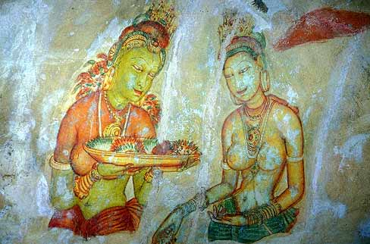

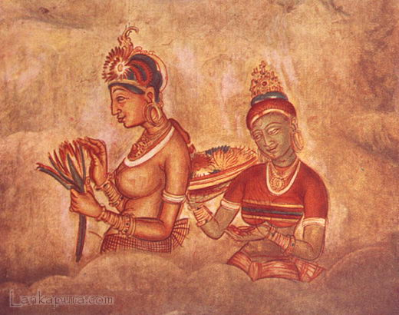

wxl 17 f,fkys wmaird rEm iys; Ñ;% iqúfYaIS fjhs' iS.sß wmaird j,g iudk ,laIK olajk njg úpdrlhska woyia lrk fuu is;=jï j,ska"

**uo iskyj" os.= fk;a" Y%sjdNrK"**

ldka;djka i`oyd w,xldrh jeä lr we;'

* **wcka;d Ñ;%j, iqúfYaIS ,laIK**
* wjia:dfkdaÑ; ye`.Sï m%ldYh yd kdgHuh whqßka wjia:d ksrEmKh
* ñksia yd i;a;aj rEmj, .;s iajNdjh" p,kh" mßudK ,laIK yd Ôjudk nj u;= lsÍu'
* uq," ueo" w. wkqj wLKav l:k l%ufhka l:dj ksrEmKh'
* iajNdúl mßirh yd jk i;=ka pu;aldrj ksrEmKh lsÍu'
* f,ka úhka;, u,a ,shlï" yia;s" udkj yd mlaIs rEm iïñY%Kfhka ks¾udKYS,Sj w,xldr lsÍu'
* .=re j¾Kfhka f¾Ld igyka lr miqj j¾K fhoSu'
* ud;Dldj jvd;a ;%Sj% lsÍug w`ÿre j¾K yd oSma;su;a j¾K Ndú;h'
* úh,s noduh u; ^ fm%iaflda iSflda & l%uhg Ñ;% we`oSu'
* **moaumdKS fndaêi;aj rej**

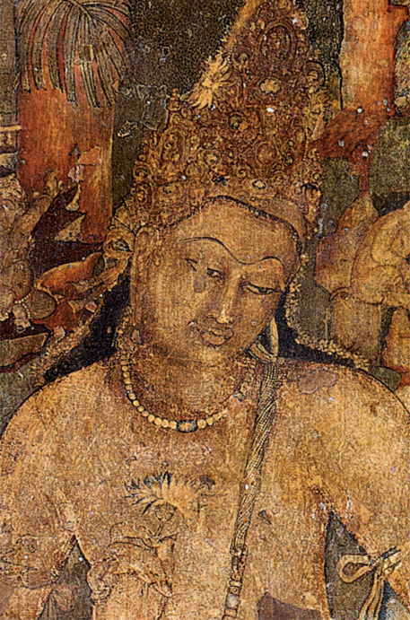

wxl 01 f,fkys we;s fuu Ñ;%fhka ukqf,dj isák isoaOd¾: l=ure yd hfYdaOrd foaúh;a" ùKd jdokh lrk foúhka yd .ia Wvq j`ÿrka lsysm fofkl=;a fiiq rEm;a tlu ;,hla ;=< iïmsKavkh lr we;'

fndai;a rej ;%syx. yevfhka ks¾udKh lr we;s w;r wOHd;añl .=Kh;a msßmqka ldreKHh;a uekúka olajd we;' .=ma; l,d ,laIK fmkajk fuu ks¾udKfhys fndaêi;ajhka wf;ys ks,a uyfk,a u,la we;s w;r rEmh úYd,j;a m%Odkj;a ks¾udKh lr we;'

* **nqÿrcdKka jykafia lsUq,aj;a mqrhg jevu ùu'**

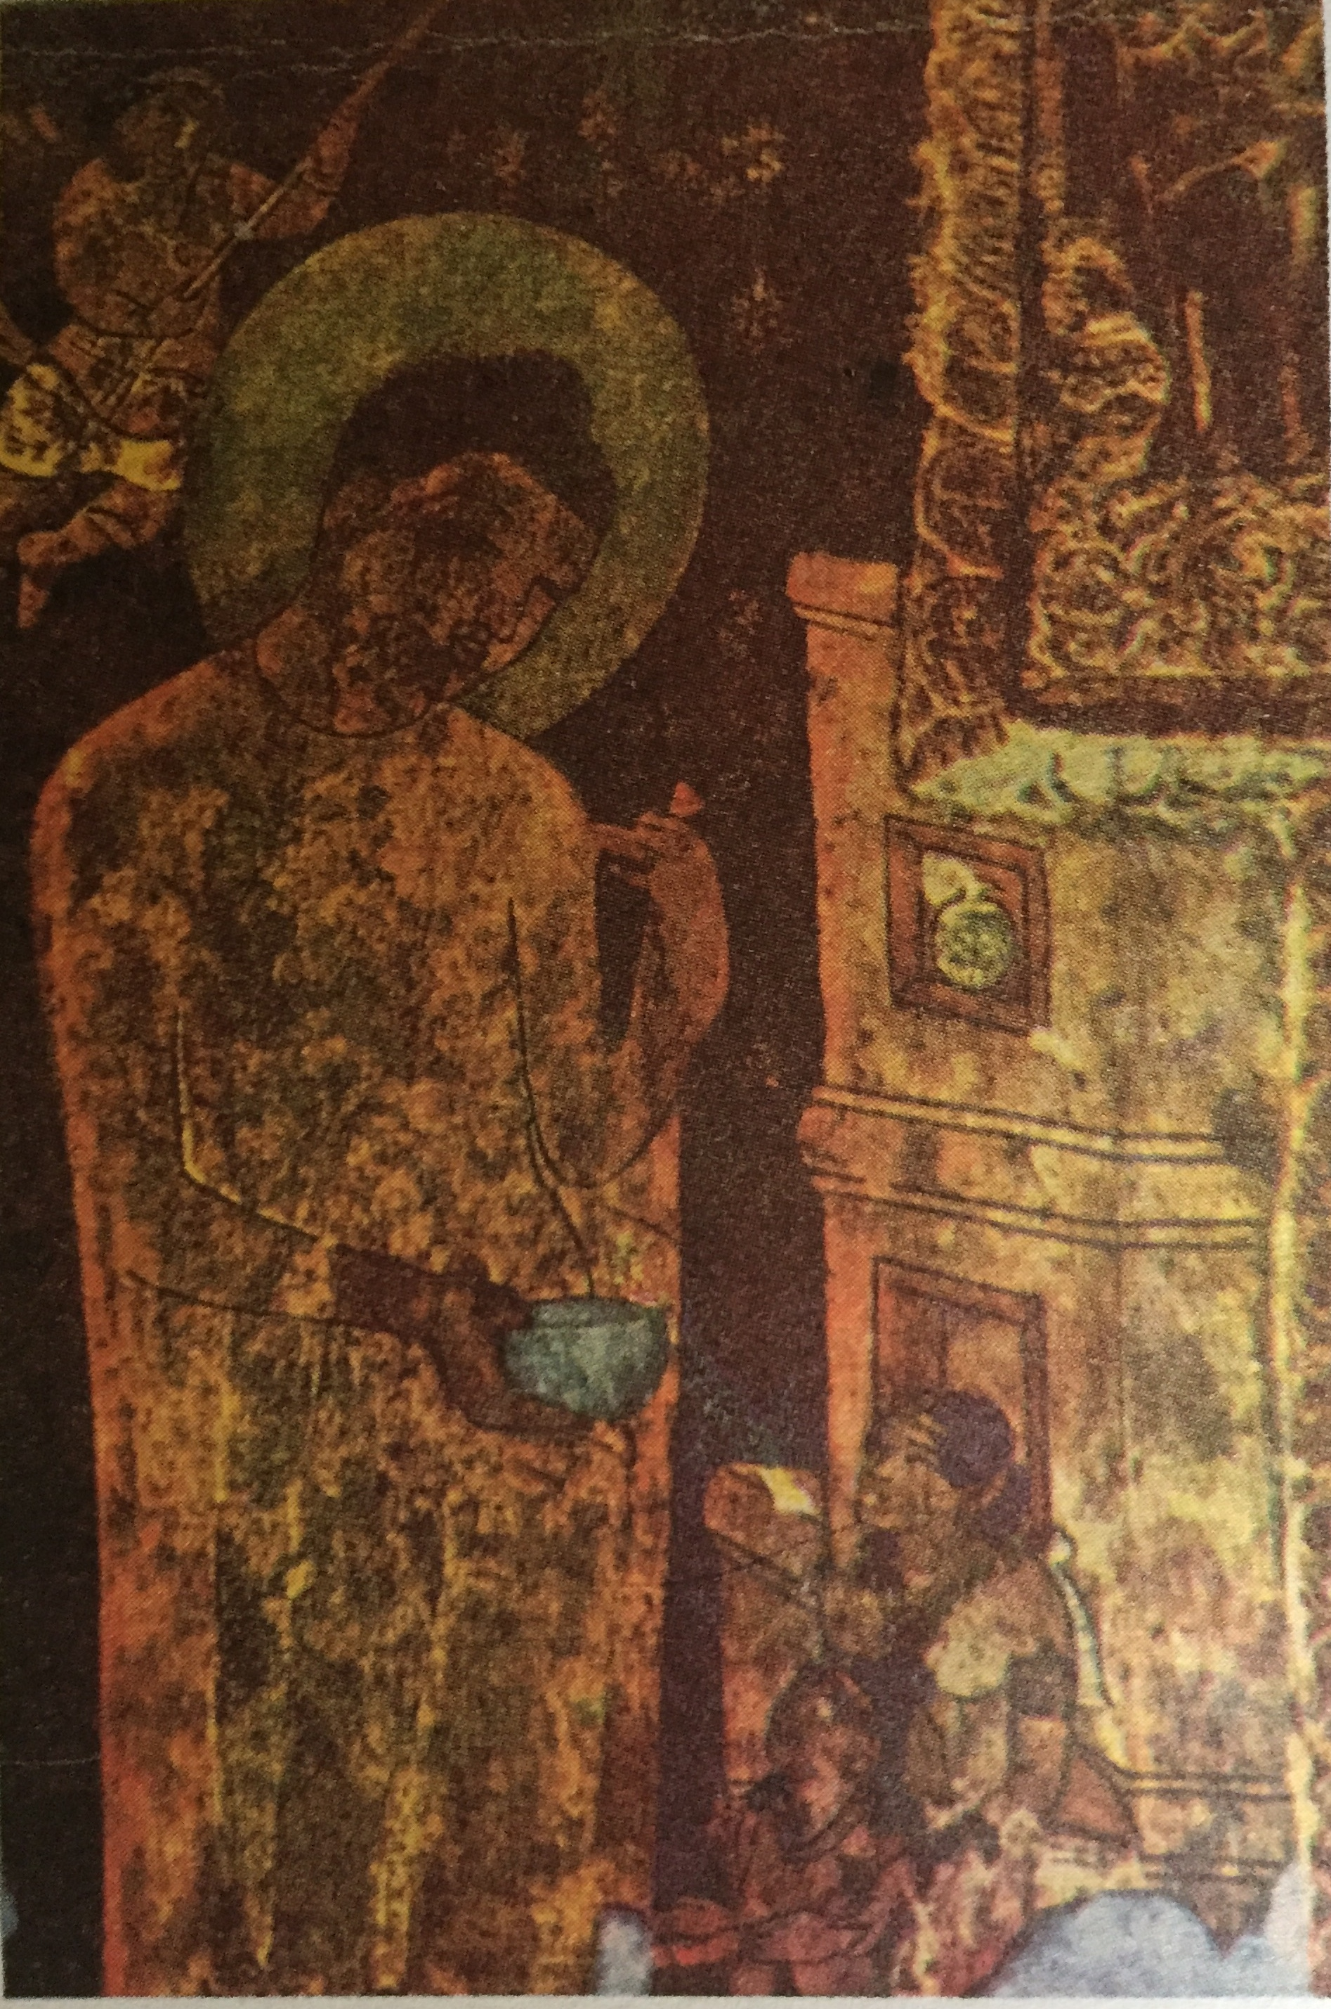

17 jk f,fkys oel.; yels fuu is;=jñka nqÿka jykafia lsUq,aj;a mqr ms`vq is`.d jäk wjia:dfõoS hfYdaOrd foaúh rdyq, l=ureg ;u mshdKka y`ÿkajdfok wjia:dj ksrEmKh fjhs' nqÿkaf.a rej úYd,j;a wjfYaI rEm l=vdjg;a olajd ;sîu ;=,ska nqÿkajykafiaf.a W;a;r;r Ndjh fmkakqï lsÍug .;a W;aidyhla f,i fuu iïmsKavkh y`ÿkajd osh yelsh' m¾hdjf,dal ,laIK iys; fuu Ñ;%h .=ma; l,d ,laIK iys;j ks¾udKh lr we;'

Art Tute

St. Joseph’s College

Colombo 10